Michael H.
Artifact Paper
The Effect of German Nationalist Philosophies on the Morality of Wartime Sciences and Conduct

It is dawn, somewhere on the front line. A pair of British “Tommies” surveys the cracked and broken landscape from the fire step. In the cobalt gloom, they can just make out the enemy trench, through a landscape of bodies and twisted wire. Word of an imminent attack has made its way down the line, and the air is thick with anticipation. Then finally, the silence is broken by a scream that rends the air and chills the blood. Shells from the enemy guns slam home, showering the trench with mud, debris, and bits of the deceased. The line fills with bleary-eyed soldiers, scrambling for ammunition and equipment. But something has caught the eye of one of the sentries. With growing dread, he adjusts his crude periscope to take a better look at the battlefield. Sure enough, a greenish cloud is creeping towards the British line, hungrily swallowing the horizon. Within seconds, the alarm is raised, “Gas! Gas! Masks on, boys!” Moments later, the cloud hits them. Those who have reacted in time, made grotesque by glassy-eyed masks, watch helplessly as their less-lucky comrades crumble, their lungs failing. A year later, German soldiers watch in horror as lumbering machines on treads roll towards them, like monsters from the gates of Hell. Almost thirty years after that, the world shakes to a blinding light, as a city in the North Pacific is flattened in seconds. All of these scenes are products of the creation of total warfare during the First and Second World War. During the early Twentieth Century a new brand of combat emerged, one that demanded the creation of new and deadlier weaponry. Within forty years, the world went from horses to weapons of mass destruction. What was to blame for this sudden escalation? How could mankind possibly justify dreaming up more efficient ways to wipe itself out? The answer can be found in the philosophies and ideals of the late Nineteenth Century and early Modern Age. Theories like Marx’s ‘Dialectical Materialism’ and Nietzsche’s ‘Superman’ brought rise to groups like the German National Socialists, who grew into the Nazi Party. Germany and the German people were especially susceptible to the ideas of men like Hegel, Bismarck, and later, Adolf Hitler. Convinced that war had become the true test of not only bravery (as previous generations had believed) but also of superiority and national destiny, the Germans pressed themselves to procure victory by any means. While there is no doubt that cruelty and horror had existed in warfare before, the First World War marked a greater scale of atrocity that brought wartime morality into the public forefront. Never before had the entire world been rocked in a single conflict. Thousands could perish within days. Following the lead of Germany and its ‘Wehrmacht’ the global powers of the First World War utilized philosophy to create the first instance of total war, causing a degradation of the morality and ethicality of wartime conduct.

At the end of the Nineteenth Century, Germany’s society and economy rapidly advanced, which lead to a massive sense of nationalism within the German-speaking peoples. Not long before the beginning of the century, Germany, like Britain, America, and other powers of the world, industrialized. Under Otto Von Bismarck, leader of Prussia, the country went from a collection of small provinces and regions to a unified nation. As a result, the Germans believed that they had become a righteous and unified people. They alone stood as an ideal society, and could easily conquer the enemy on the battlefield. Nobody could be allowed to stand in the way of the country’s new and beautiful era. Anything that occurred in combat, then, as long as it brought the country closer to it’s perfect state, was not only pardonable, but also necessary.

Bismarck was the driving force behind Germany’s development as a country. First, to unify the country, he supported an almost socialist platform, promising rights, healthcare, and other benefits to the new middle class. Then, he scapegoated minorities, including Catholics, who were loyal to the Pope, and Socialists. He started a campaign of intense military expansion, first taking over provinces of German-speaking people in countries like Denmark, and then forcefully sending his armies in to take land at will. He granted a province to Austria, and then, when they attempted to reach it, he vanquished their armies. After a number of wars, including the Franco-Prussian War, and the Austria-Prussian War, the Prussians controlled much of the Empire. Bismarck signed a treaty to purposefully keep Austria out of German politics. He also ordered the construction of a railroad, which provided an easy way to transport goods and, more importantly, troops, wherever they were needed. In fact, it was by way of the railroad that German soldiers rode into Paris towards the end of the Franco-Prussian War. Germany produced the coal and steel to make the railroads, making the country’s economy rich. To this end, by the beginning of World War 1, Germany was one of the richest, and most technologically advanced nations in the world.

This rapid industrialization was not without consequence, however. Thanks to the speed of its change, and the violence with which the borders expanded, the German people began to glorify their unity and power. Just before the outbreak of war, German philosophers began to theorize that Germans had descended from a superior nation. In 1914, the country was overcome in an outpouring of Nationalism, a massive and sudden support for the military and the inevitable war. German politicians, even those who vehemently opposed entering into a conflict, were helpless in the face of mass gatherings, student demonstrations, and other public rallies. This time period became known as “the spirit of 1914” or the “ideas of August.” Ernst Toller, a man who would later become a determined opponent of war, was a perfect example of this national high, when he said, “The nation recognizes no races anymore; all speak one language, all defend one mother, Deutschland.” The unified people, no longer a “rabble” (as one unknown commentator described them) had fallen in love with the idea of being an enlightened nation. Once this strong public opinion had been established, especially in schools, where impressionable and patriotic college students were already preparing for war, there was no possible way to avoid conflict. Thanks to a warm spring, there was nothing to repress the excitement of the people. They held parades, marches, and meetings. As the newspapers arrived, huge crowds would gather in the streets, clamoring for a national “spring” to take place alongside that of the climate. The politicians had no choice. Any other move besides a declaration of war would probably have been met with riots. On August 1914, Germany declared war on Russia, and two days later, on France.

It was during the war, however, that the real philosophy of the German people would emerge. With its violent history, and the eagerness with which its people enlisted, it should come as no surprise that Germany would carry a different idea of conflict than that of other nations. More so than others, the country was a product of men like Hegel, Nietzsche, Schopenhauer, and Marx. Like Hegel, many Germans believed that progress would be borne in the hands of combat and battle. Thanks to Nietzsche, they also believed that war revealed the inner nature of man, and that the winner would be he who harnessed this dark power. Helmuth Von Moltke theorized that total war was the new test of man. It was the greatest deed in war to him, as long as it brought a swift end. He said, “Every means to that end, so long as it is not reprehensible, must remain open… All the sources of support for the hostile government must be considered: its finances, railroads, foodstuffs, even its prestige.” (Von Moltke) In other words, you destroy not only soldiers, but also everything that supports them. General Friedrich Von Bernhardi claimed, “Without war, inferior or decaying races would easily choke the growth of healthy budding elements, and a universal decadence would follow...Strong, healthy, and flourishing nations increase in numbers...Since almost every part of the globe is inhabited, new territory must, as a rule be obtained at the cost of its possessors-- that is today, by conquest, which thus becomes a law of necessity.” (Von Bernhardi) The Germans, believing that they were the ‘chosen people’, knew that the best way to advance their country was to end the war quickly, and use that war to eradicate other groups. Most did not fight for this, but politicians used the idea of the ‘Reich’ to manipulate the enthusiasm of the people. The effect was the same as the British Armies telling men that they fought for honor, duty, and to uphold the international codes of conduct. French and Russian leaders told their people that they fought for self-defense of their lands. When the Germans pressed their scientists to develop military technology of questionable morality, the Allies had no choice but to follow suit. It was the “everything to lose” nature of the war that brought mankind to dream up increasingly dangerous weapons, culminating in the Atomic Bomb at the end of the Second World War.

Like science, art was put towards the war effort. It was soon realized that, just as it would be necessary to study science to develop new weapons, in the face of a reality that would cripple support for the war, it was also necessary to gloss over the war with art. To keep the homefront happy and patriotic, and the soldiers on the front heartened, countries all around the world contributed large amounts of their budget to the production of posters, resource drives, presentations, and, during world war 2, cartoons. Even Walt Disney produced a collection of anti-German and anti-Japanese films during the 1940s. Propaganda in many countries made use of a psychological theory that had recently come about in the 1890s, called Gestalt. Gestalt grew out of the ideas of men like Johann Wolfgang von Goethe, and Immanuel Kant. Gestalt was the study of visual images, and their effect on the subconscious mind. Some thinkers had realized that visual images could carry a certain feeling or emotion with them. When people saw a picture, they made unconscious associations, connections, and assumptions about what they were seeing. This type of thinking was revolutionary. An audience’s thinking could be manipulated, without them even realizing it. According to some of the principles of Gestalt, people could associate disconnected shapes into a larger shape, recognize geometric objects no matter their rotation or scale, and group images. It should come as no surprise, then, that Gestalt theory was immediately thrown into the world’s media, and the propaganda engine. Governments could surreptitiously increase their people’s hatred for an enemy by bombarding them with images and articles meant to sway the mind. They placed enemy uniforms on monsters and images of death. On recruitment posters, friendly soldiers were always shown in heroic golden light, striding into the heat of battle. As a result, the zeitgeist, or spirit of each nation, and what they wished to get out of the war became reflected in each country’s media. Movies, posters, newspapers, photography; all were infused with the war effort in mind.

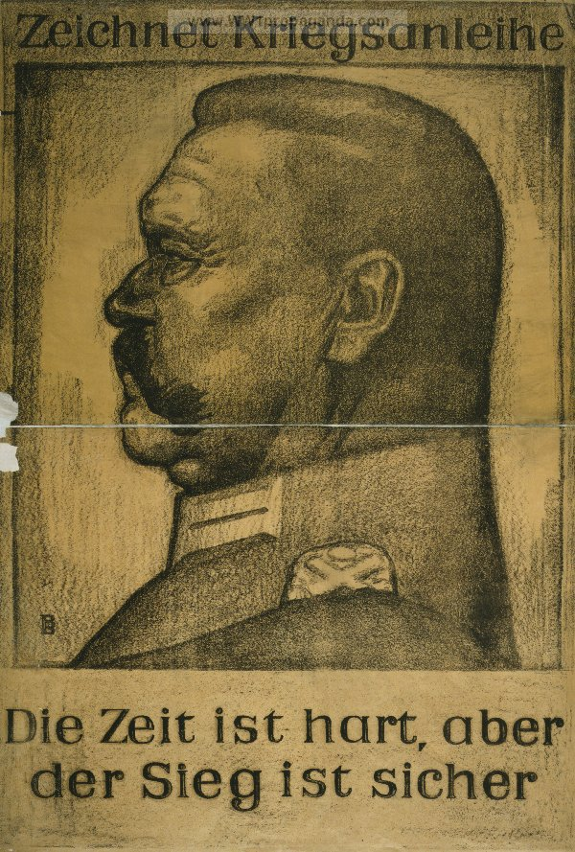
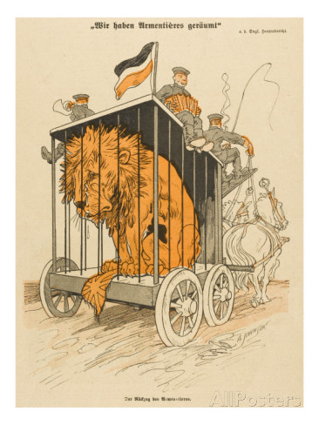
One country that relied heavily on propaganda to keep up the spirit of the people was, of course, Germany. In the beginning of the First World War, posters helped to drum up support for the decision to declare war, as well as to enlist in the Wehrmacht. Then, once the fighting began, it was soon clear that it was even more necessary to protect the innocence of the homefront, as the soldiers became accustomed to the new brutality of battle. Bodies of Germans were rarely seen on film, and word of retreat or setback was not passed on. People back home could not know about the hundreds of their husbands, brothers, and sons who were being incinerated in the trenches on the front. But they also needed to keep up a steady fear or hatred of the enemy. Besides posters, newspapers were doctored as well. Fictional headlines spewed from the presses, bearing articles such as, “French doctors infect German wells with plague germs” and “German prisoners blinded by Allied captors.” The Germans did not concentrate as much of their media on recruiting, considering the massive size of the Wehrmacht at the outbreak of the war. Rather, the problem that the German Government faced around the middle of the war was continuing the fight. After awhile, it became clear that, not only was victory not going to come easily, but the nationalist spirit too was not enough to keep Germany in the war, especially as more and more of her young men returned in boxes. So the government turned to censorship and pro-German images. One advertisement for war loans depicts a muscular, heroic soldier with one arm draped protectively over his wife and newborn child, and the other holding a bayonet. The text can be loosely translated into, “War loans help the guardians of your happiness.” Another advertisement for war bonds shows a man’s face in profile, presumably an officer of the army, still in uniform. His eyes are weary, but his expression remains determined. The bottom of the poster reads, “The time is hard, but victory is certain.” These posters were definitely targeted at the home audience, assuring them that, although the losses were high, victory was near. It paints the German soldiers as larger than life heroes, the embodiment of the unconquerable spirit that Germany tried to keep up. Yet another poster takes a more jovial approach, showing a number of cheerful soldiers, who are playing traditional instruments and smoking pipes, riding a cart with a cage on it. In the cage sits a downtrodden lion. The text reads, “The Germans have caged the British Lion.” The soldiers on the cart seem to be a celebration of the German culture, an allusion to the goal of advancing the country to its “destiny”. Each of the posters demonstrates the national need to end the war and break the stalemate on the front line that drove Germany to develop weapons like chlorine and mustard gasses. By the end of the war, in fact, Germany clocked in as the foremost user of gas weapons in the entire war, proving the effect of national mindset on the frontline events.
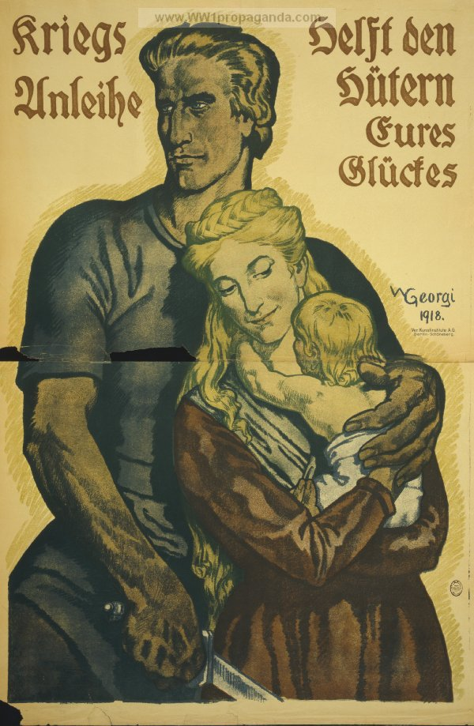
“War Loans help the guardians of your happiness.”
“The time is Hard, but victory is certain.”
“The Germans have caged the British Lion.”

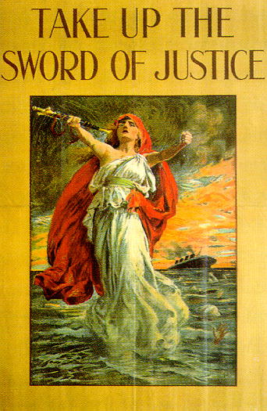
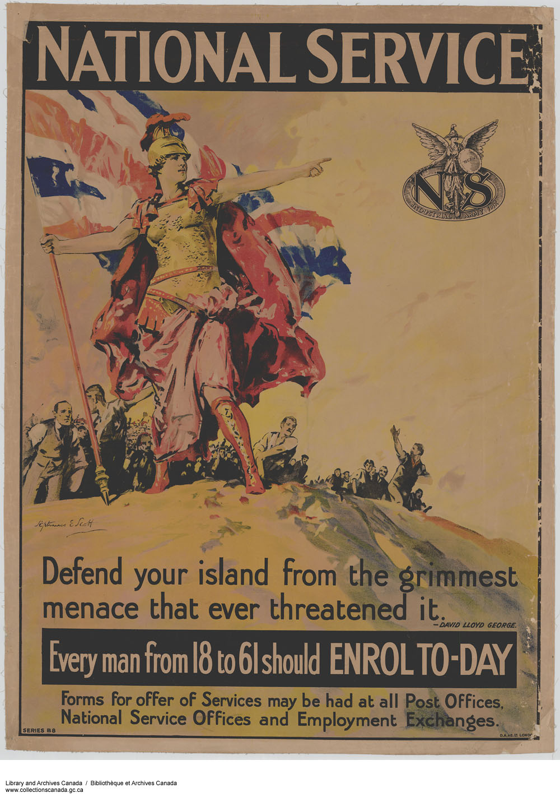
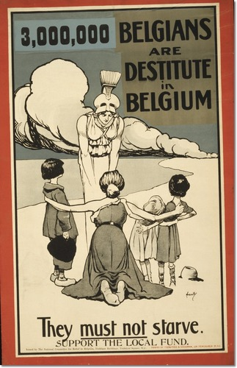
Many times, thanks to the close relationship between national spirit and propaganda, people like to believe that something related to the Central Powers could not exist in Allied Countries as well. Yet, the Allies were in no way beyond using propaganda, nor were they above deploying their own gas attacks. Great Britain also found itself in need of military media, immediately from the beginning of the war. The British armed forces were home to far fewer men than the German Wehrmacht. As soon as war was declared, and British divisions began shipping out to the front, they began to rally for more soldiers to enlist. As a result, the majority of British propaganda is a rallying call. Many times, it depicts visions of the goddess of Victory, or some other female form of liberty and justice, leading a collection of men into battle. An excellent example is one such poster that shows a woman in a toga rising from the sea, a sword held out in one hand. Behind her, an ocean liner slips beneath the stormy waves, against a sky of fire. The poster prompts the young men of Britain to, “Take up the Sword of Justice.” Another poster shows Athena, the Ancient Greek goddess of wisdom and battle strategy, leading an army of men in civilian clothes mounting a hill. It reads, “Defend your island from the grimmest menace that ever threatened it.” The British government also used propaganda to appeal to the sense of honor and duty that its people felt towards the world. To the British, it was imperative that the laws of conduct and honor be upheld in the global community. One poster, for instance, shows Athena once again, this time kneeling down to a trio of starving children. In the background, a cloud of smoke billows across the sky. The poster pleads with its audience, “3,000,000 Belgians are destitute in Belgium. They must not starve.” The British joined the war because they saw themselves as the voice of Athena, the champions of the law, and paragons of honor. Along the same lines, one British recruitment advertisement depicts the British soldier as an armored knight riding a white stallion. His golden lance is buried in the breast of a rearing dragon. The text calls out to the men on the homefront, “Britain needs you at once.” Perhaps it was the foundation of liberal philosophy on which many of the Allied powers were based, which led to their assuming of the mantle of reasoned thought and moral enforcement. Ironically, their determination to defend such ideals would give them the justification (at least in the eyes of their leaders) to make some of the darkest decisions ever seen in warfare.
“Take Up the Sword of Justice.”
“Defend your island from the grimmest menace that ever threatened it.”
“3,000,000 Belgians are destitute in Belgium.”
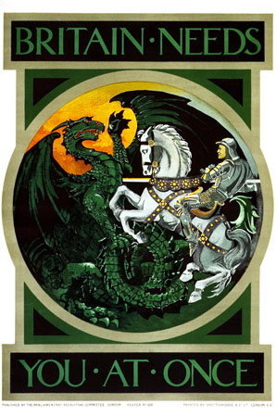
It was mainly this national feeling of protectiveness for the ‘innocent’ that kept Britain in the war. To the Allies, the Germans and other Central Powers were the forces of evil and chaos. If they won, then it truly would mean the end of the civilized world. And so, the British were prompted to up the ante alongside the Germans, matching cruelty for cruelty, in what could be described as a four-year political poker match. Each side would introduce a new weapon or tactic in an attempt to wipe out the enemy. The other side would respond in turn with their own innovations. For example, once the Germans had unleashed one of the first massive chlorine gas attacks, at Ypres, the Allies swung into action. Now both sides could use the new technology, and blame any ethical missteps on the Germans, as they had been the once to use make the first move. By the time the war was in full swing, morality concerning the use of different weapons was at an all time low. No longer was defeating the enemy army a goal. Now, each nation sought to eradicate its enemy, both civilian population and military.
“Britain needs you at once.”

The propaganda of the First World War demonstrates the transition to all-out conflict, and the idea of the war effort coming before all. Every nation, Allies and Central Powers alike, came to the decision that winning the war was the greatest good. To that end, they sacrificed the truth of the media, conduct of society, and even the laws of morality and decency, for victory. It was a change that threw mankind into a new age: an age of secrecy and intelligence. Ethical problems that governments faced in the First World War have followed society into the Twenty-first Century, possibly even intensifying in the wake of September 11th, 2001 and the War on Terror. For hundreds of years, humanity has struggled with ‘the greater good’ of the whole. Freedom, truth, and accessibility are the price for vigilance, security, and safety. The only thing that can validate the disregard of certain ideals for a perceived cause is philosophy. For instance, to the early Twentieth Century Germans, the war would bring about a perfect nation of Nietzschean supermen. To the British, anything other than victory would mean the breaking of a sacred international code of conduct and the fall of Liberal thought. To many others, like the French, the fight was for freedom and the defense of a homeland against invaders. Years before, British and Belgian Imperialists would justify their decimation of native African peoples and their land with ideas of ‘civilizing the Dark Continent’ and ‘taming the wild African.’ The Radicals of the French Revolution would strip away the rights to property and freedom by way of the ‘Levee en Masse’, an action that saved France. The world’s leaders exploited the standards and philosophies that had arisen in their respective countries, playing up the war into a stew of abstract right and wrong. A disconnect between reality and idealism. Soldiers on the front line were horrified to discover that the war of ideas concealed a darker, more primal conflict between life and death. Others however, including native German, Ernst Junger, were almost delighted to perceive the liberation of natural humanity from the shackles of its morality and rationality.

Ernst Junger was a German philosopher and writer, who saw first hand experience of the Wehrmacht and its aftermath during the First World War. Unlike much of the world, however, Junger did not see the sudden brutality and scale of combat as a bad thing. Instead, he believed that the new form of war was actually a test of man, a divine event that brought humanity out of their pitiful forms, and exposed their true power. As a right-wing writer, his ideas represented the thoughts of many radical Germans of the time. The right wing National Socialist Party in Germany advocated for the swift unification of the German-speaking peoples. Its leaders believed that Germany had existed once as a golden (and completely fictional) state, which they called the ‘First Reich’. During the early twentieth century, two attempts were made to reestablish the Reich, with Bismarck leading the Second Reich, and Adolf Hitler fighting for the Third Reich. Indeed, the National Socialists in Germany grew directly into the Nazi Party, almost twenty years after the end of the First World War taking Nietzsche’s idea of a superman, and adding race to it. The Nazis believed that only the Aryan Race could possibly be a superior species. Junger, and other thinkers of World War 1, instead believed that the men who could survive the test of the war could be superior.

In an essay titled War as an Inner Experience, Junger writes: “As sons of an age intoxicated by matter, progress seemed to us perfection, the machine the key to godliness, telescopes and microscopes organs of enlightenment. Yet underneath the ever more polished exterior, beneath all the clothes in which we bedecked ourselves, we remained naked and raw like men of the forest and the steppes…Then it was that, in an orgy of frenzy, the true human being made up for everything he had missed. At this point his drives, too long pent up by society and its laws, became once more the ultimate form of reality, holiness, and reason. . .” (Junger) As he looked at it, war ripped away the trappings and other frivolity of the European Spirit, placing man in his natural element. To Junger, the superior man did not crumble beneath the loss of this civilization, but rose to the challenge, harnessing the inner Id, and its animal instinct to become the Nietzschean “superman.” He says that the war “ripped asunder the community of Europe,” and that the soldiers on the battlefield “confronted each other in a primordial contest behind flags and symbols which many skeptics had long mocked.” Junger writes about man breaking free of the laws of society, to become “the true human being.” This was the basis of the German mindset, the main reason why the German people were driven to come together, not once, but twice. To Junger, the men who could reconcile the horrors of war, and the terribleness of their actions, could rise to become the leaders of a new age.

The World War era demonstrated once again to mankind that large-scale atrocities were still possible, even in the Modern Age. It is no surprise that the German philosophical tradition of progress through conflict, and hope of establishing a perfect nation would end up clashing with the more liberal beliefs of the Western Europeans. This conflict, as well as the political backdrop against which it was set, culminated in the largest war that had ever entered modern conception. The philosophies to which each nation clung during the war made it all the more violent, bitter, and unyielding. Moreover, the necessity to win was founded in every country’s individual school of thought. Ultimately, it was this necessity to win that sent mankind to test the limits of what was acceptable or defensible in the global community.
Works Cited
Bernhardi, Friedrich Von, and Allen H. Powles. Germany and the next War.
New York: Longmans, Green, 1914. Print.

Duffy, Michael. "Firstworldwar.com." First World War.com. N.p., 22 Aug. 2009. Web. 1 May 2014.

Eksteins, Modris. "Sacred Dance." Rites of Spring: The Great War and the Birth of the Modern Age. Boston: Houghton Mifflin, 1989. N. pag. Print.

Eksteins, Modris. "Rites of War." Rites of Spring: The Great War and the Birth of the Modern Age. Boston: Houghton Mifflin, 1989. N. pag. Print.

Junger, Ernst. "War as an Inner Experience." Editorial. 1922: n. pag. Print.

Spragins, James. "Class Discussion." Class Discussion. Gilman School, GC202, Baltimore. Apr. 2014. Lecture.

Trueman, Chris. "Poison Gas and World War One." Poison Gas and World War One. N.p., n.d. Web. 1 May 2014.

Trueman, Chris. "Propaganda and World War One." Propaganda and World War One. N.p., n.d. Web. 4 May 2014.

Von Moltke, Helmuth. "On the Nature of War." Letter. 11 Dec. 1880. N.p.: n.p., n.d. N. pag. Print.

"World War 1 Propaganda Posters." World War 1 Propaganda Posters. Jiggsy Communications, LLC, 2011. Web. 4 May 2014.

"World War 1 Posters." World War 1 Propaganda Posters. N.p., n.d. Web. 12 May 2014.

