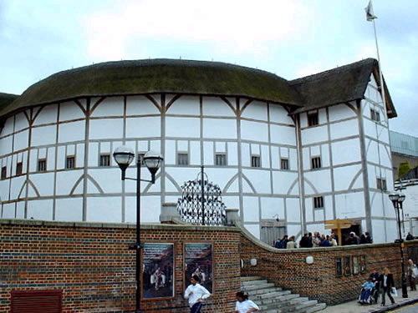
http://www.english-online.at/history/elizabethan-theatre/shakespeares-theatre.htm

By
Grant Lounsbury
&
Joe White

Act 2 Scene 2 lines 1-74

Lady Macbeth- Grant Lounsbury
Macbeth- Joe White
In this act of the play, Macbeth returns in the middle of the night, just having murdered Duncan. He recounts to Lady Macbeth the strange noises the attendants made during the murder, and admits that it has disturbed him. She admonishes him and takes control, destroying the evidence of their deed and planting false evidence to implicate the grooms in the murder.

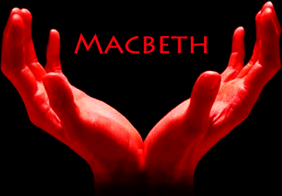
http://www.tyburnoperas.com/macbeth-a1s2.htm

SET DESIGN
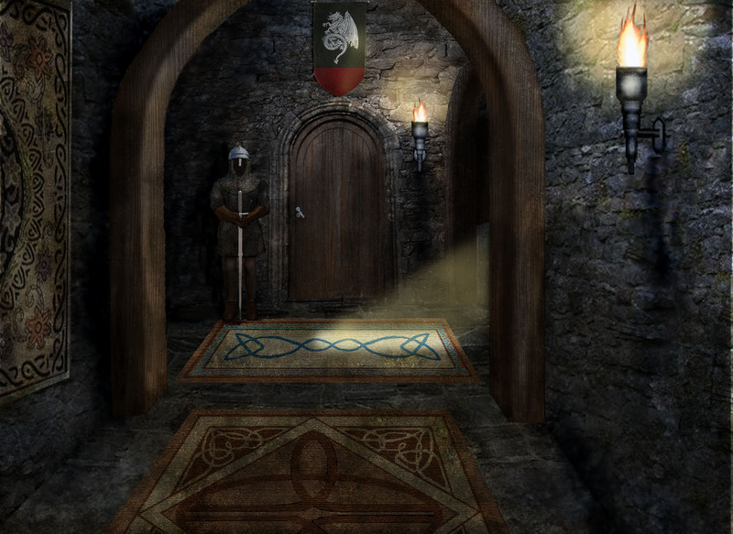
http://www.brokenattitude.com/games.html
The dark corridor lit by torches is appropriate both for the nighttime setting and the thematic darkness of the scene. The roughly hewn stone corridor is typical of a medieval castle; these building were not palaces of leisure like Versailles but rather military fortresses built to withstand siege, as Macbeth does in the final Act of the play
The door at the end ties in this corridor to the one in Carey Hall where we performed; it is the door to Ms. Hammer’s office and in the play it would be the great entrance to the castle that was battered down by Macduff
This picture resembles the second floor architecturally because there is a corridor leading up to the door which forms a T and branches out to either side, as shown by the great archway and the light streaming in
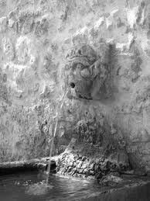
http://family.webshots.com/photo/2730259440082614526YfRzBY
This fountain is where Macbeth washes his hands of the blood. It symbolizes his attempt to distance himself from the deed, and in Carey Hall it is represented by the water fountain.
The picture is dark and framed against a stone wall, so it fits in with the earlier castle.
COMPANY REPORT
- What happens in your scene? Outline the basic events.
- Macbeth describes how he murdered Duncan, and the evidence of this is the blood on his hands and on the swords that he brings from Duncan’s room.
- After he murders Duncan, he starts to show sings of guilt, and remorse, which lead to his wife, Lady Macbeth, taking control and devising a plan, so that they may not be charged with the murder of the king.
  - She disguises the deed that they have committed by smearing the grooms with blood, and laying the swords near their room.
    - They frame the grooms.
- After Lady Macbeth does this, they go back to sleep as if nothing had happened that night.
2. What do you think are the key purposes of your scene?
- A key point in this scene is that Macbeth is starting to go insane due to him murdering Duncan.
  - This is exemplified by the loss of sleep that he undergoes
    - The groom cries “Glamis hath urdered sleep, and therefore Cawdor shall sleep no more; Macbeth shall sleep no more,” (2.2.41-2).
    - This ties in the murder with the resultant loss of sleep, and insomnia is one of the many side effects of Macbeth’s mounting insanity
- When Macbeth says “They pluck out mine eyes!” (2.2.58), He shows remorse for what he has done.
  - This is related to Oedipus because he too showed remorse for the crimes that he had committed, culminating in his own insanity; Macbeth’s quotation of such a tragedy is the best way of describing his own tragedy.
- Another key point in this scene is that Lady Macbeth is becoming even more controlling of Macbeth. After she forces him to do one job for her, she sends him out again to do another job.
3. How does this scene fit into Shakespeare’s overall purpose in the play?
Shakespeare’s purpose of writing his plays was to make a living, and to do that he had to please his patrons. These wealthy men meant the difference between poverty, ignominy, and failure or success and power. Try as he might to achieve artistic goals with his writing, Shakespeare was ever-conscious of his audience, which according to R.C. Bald in his Macbeth and the Short Plays (Oxford Review of English Studies) would probably have been the royal court at Blackfriars Theater. This play therefore would have been meant to appeal to King James, especially because of the apparent revisions made for its performance at Blackfriars which are present in the surviving version of the play. In this scene Shakespeare clearly condemns regicide, as Macbeth’s committal of such a heinous crime goes unpunished for a long time but he reaps no joy from it. In fact, he feels so bad that ‘to know my deed, twere best not know myself,” as he says in the scene after committing the crime (Shakespeare 2.2.72-3). Secondly, Banquo is King James’ ancestor, and in this scene Banquo’s predictions come true about the witches’ prophecy. Seemingly good, it has led Macbeth to commit great evil, just as Banquo feared. Finally, King James would have been especially sensitive to plots against the government having suffered one just a year before Macbeth was written. In 1605, Guy Fawkes infamously tried to blow up Parliament and thus kill King James and his entire family, a plot which failed but left such an impact on the national consciousness that it is still remembered today.

In-Depth Analysis of Shakespeare’s Writing
In Shakespeare’s play Macbeth, he shows the incredible finesse required for a great play. Shakespeare did not write action packed plays like today’s Hollywood productions. Rather, most fighting took place offstage, and Shakespeare exploited this to build dramatic tension. Because the audience has not seen the murder, they do not know whether it has been successful, and Lady Macbeth builds the suspense by voicing the audience’s fear: “I am afraid they have awaked, and ‘tis not done.” (2.2.9-10). The audience then sees Macbeth enter, with bloodied blade and broken brain, and the suspense reaches its climax. Macbeth resolves the question bluntly with his matter-of-fact statement, “I have done the deed,” (2.2.14). In order to preserve this tension, we have likewise kept all the action offstage and trimmed the opening lines to the key plot points in order to maintain interest. Another stylistic decision we made was to keep, beyond the basic plot, the lines that preserved the atmosphere and symbolic message of the play. Some symbols include the water Macbeth washes his hands with upon Lady Macbeth’s assertion that “a little water clears us of this deed,” (2.2.66), which serves as an allusion to Pontius Pilate’s washing of his hands to avoid responsibility for Jesus’ death. Shakespeare used few props in his plays, and we did likewise, but we made sure to use the water fountain for this part because of its significance. We began our play with a foreboding owl’s screech, symbolic because of owls’ role as “harbingers of bad luck, ill health, or death,” according to Bruce G. Marcot in his “Owls in Lore and Culture” (http://www.owlpages.com/articles.php?section=Owl+Mythology&title=Owls+Lore+Culture&page=8); Lady Macbeth references this in her opening line, “It was the owl that shrieked, the fatal bellman,” (2.2.3). Furthermore, we used our third and final prop to put fake blood on Macbeth and Lady Macbeth’s hands which signifies their guilt, as Lady Macbeth establishes when she refers to it as a “filthy witness” (2.2.45-6), the testament to their crime. In short, our three props reflect the sparse Shakespearian style of play production, yet each of the props were selected because of their symbolic importance. Our final choice of production style, besides the offstage action and the focus on symbolism in the retention of lines, was the use of body language to supplement the written text. Macbeth is questioning himself in an unwonted moment of self-examination about his inability to say “amen,” and in a broader sense his sense of unworthiness before God. Lady Macbeth tries to comfort him in a similarly unwonted display of affection, saying “These deed must not be thought after these ways: so, it will make us mad” (2.2.33). Therefore to emphasize the disparity between her present actions and her normal state of character, we had her reach out and touch Macbeth to comfort him; the physical contact alerts the audience to a significant line, because it is a ‘hand moment’ as Mr. Christian would call it. The line is important, because it foreshadows the madness which will in fact afflict both of them. A good play contains the attributes mentioned above, such as dramatic tension, symbolism, and body language; our script, props, and acting reveal our emphasis on these qualities. However, a great play must speak to audiences on many levels, for each viewer will perceive it differently, and therefore a great play must be flexible enough that each person can derive something different from it. This was something that Shakespeare himself excelled at, and is the reason for his success and continuing influence.

PROMPT PAGES
Enter LADY MACBETH
Owl Shrieks
LADY MACBETH
That which hath made them drunk hath made me bold;
What hath quenched them hath given me fire.
(Shouting) Hark! Peace!
It was the owl that shrieked, the fatal bellman,
Which gives the stern’st good-night. He is about it:
The doors are open; and the surfeited grooms
Do mock their charge with snores: I have drugged
their possets,
That death and nature do contend about them,
Whether they live or die.
MACBETH
[Within] Who’s there? What, ho!
LADY MACBETH
Alack, I am afraid they have awaked,
And ‘tis not done. The attempt and not the deed
Confounds us. Hark! I laid their daggers ready;
He could not miss ‘em. Had he not resembled
My father as he slept, I had done’t.
Enter MACBETH
My husband!
MACBETH
I have done the deed. Didst thou not hear a noise?
LADY MACBETH
I heard the owl scream and the crickets cry.
Did not you speak?
MACBETH
When?
LADY MACBETH
Now.
MACBETH
As I descended?
LADY MACBETH
Ay.
MACBETH
Hark!
Who lies I’ the second chamber?
LADY MACBETH
Donalbain.
MACBETH
This is a sorry sight.
Looking on his hands
LADY MACBETH
A foolish thought, to say a sorry sight.
MACBETH
There’s one did laugh in’s sleep, and one cried
‘Murder!’
That they did wake each other: I stood and heard them:
But they did say their prayers, and addressed them
Again to sleep.
LADY MACBETH
There are two lodged together.
MACBETH
One cried ‘God bless us!’ and ‘Amen’ the other;
As they had seen me with these hangman’s hands. (Looks at Hands)
Listening their fear, I could not say ‘Amen,’
When they did say ‘God bless us!’
LADY MACBETH
Consider it not so deeply.
MACBETH
But wherefore could not I pronounce ‘Amen’?
I had most need of blessing, and ‘Amen’
Stuck in my throat.
LADY MACBETH
- (Walks up to Macbeth and pats his shoulder comfortingly)
These deeds must not be thought
After these ways; so, it will make us mad.
MACBETH
Methought I heard a voice cry ‘Sleep no more!
Macbeth does murder sleep’, the innocent sleep,
Sleep that knits up the raveled sleeve of care,
The death of each day’s life, sore labor’s bath,
Balm of hurt minds, great nature’s second course,
Chief nourisher in life’s feast,--
LADY MACBETH
(Cautious) What do you mean?
MACBETH
Still it cried ‘Sleep no more!’ to all the house:
'Glamis hath murdered sleep, and therefore Cawdor
Shall sleep no more; Macbeth shall sleep no more.'
LADY MACBETH
Who was it that thus cried? Why, worthy thane,
You do unbend your noble strength, to think
So brainsickly of things. Go get some water,
And wash this filthy witness from your hand.
Why did you bring these daggers from the place?
They must lie there: go carry them; and smear
The sleepy grooms with blood.
MACBETH
I'll go no more:
I am afraid to think what I have done;
Look on't again I dare not.
LADY MACBETH
Infirm of purpose! (Slaps Macbeth)
Give me the daggers: the sleeping and the dead
Are but as pictures: (Macbeth gives Lady Macbeth the daggers) 'tis the eye of childhood
That fears a painted devil. If he do bleed,
I'll gild the faces of the grooms withal;
For it must seem their guilt.
Exit. Knocking within
(off stage Lady Macbeth drops off daggers and bloodies her hands)
MACBETH
Whence is that knocking? (Confused, looks around searchingly)
How is't with me, when every noise appalls me? (Looks at Hands)
What hands are here? ha! they pluck out mine eyes.(He mimics plucking out his eyes)
(To the Audience) Will all great Neptune's ocean wash this blood
Clean from my hand? No, this my hand will rather
The multitudinous seas in incarnadine,
Making the green one red.
Re-enter LADY MACBETH
LADY MACBETH
My hands are of your color; but I shame
To wear a heart so white. (Shows her bloody hands to him)
Knocking within
I hear a knocking
At the south entry: retire we to our chamber;
A little water clears us of this deed: (Macbeth walks over to water fountain and wash hands)
How easy is it, then! Your constancy
Hath left you unattended.
Knocking within
Hark! more knocking.
Get on your nightgown, lest occasion call us,
And show us to be watchers. Be not lost
So poorly in your thoughts.
MACBETH
To know my deed, 'twere best not know myself.
Knocking within
Wake Duncan with thy knocking! (Bitterly) I would thou couldst!
Exeunt

COSTUME DRAWING
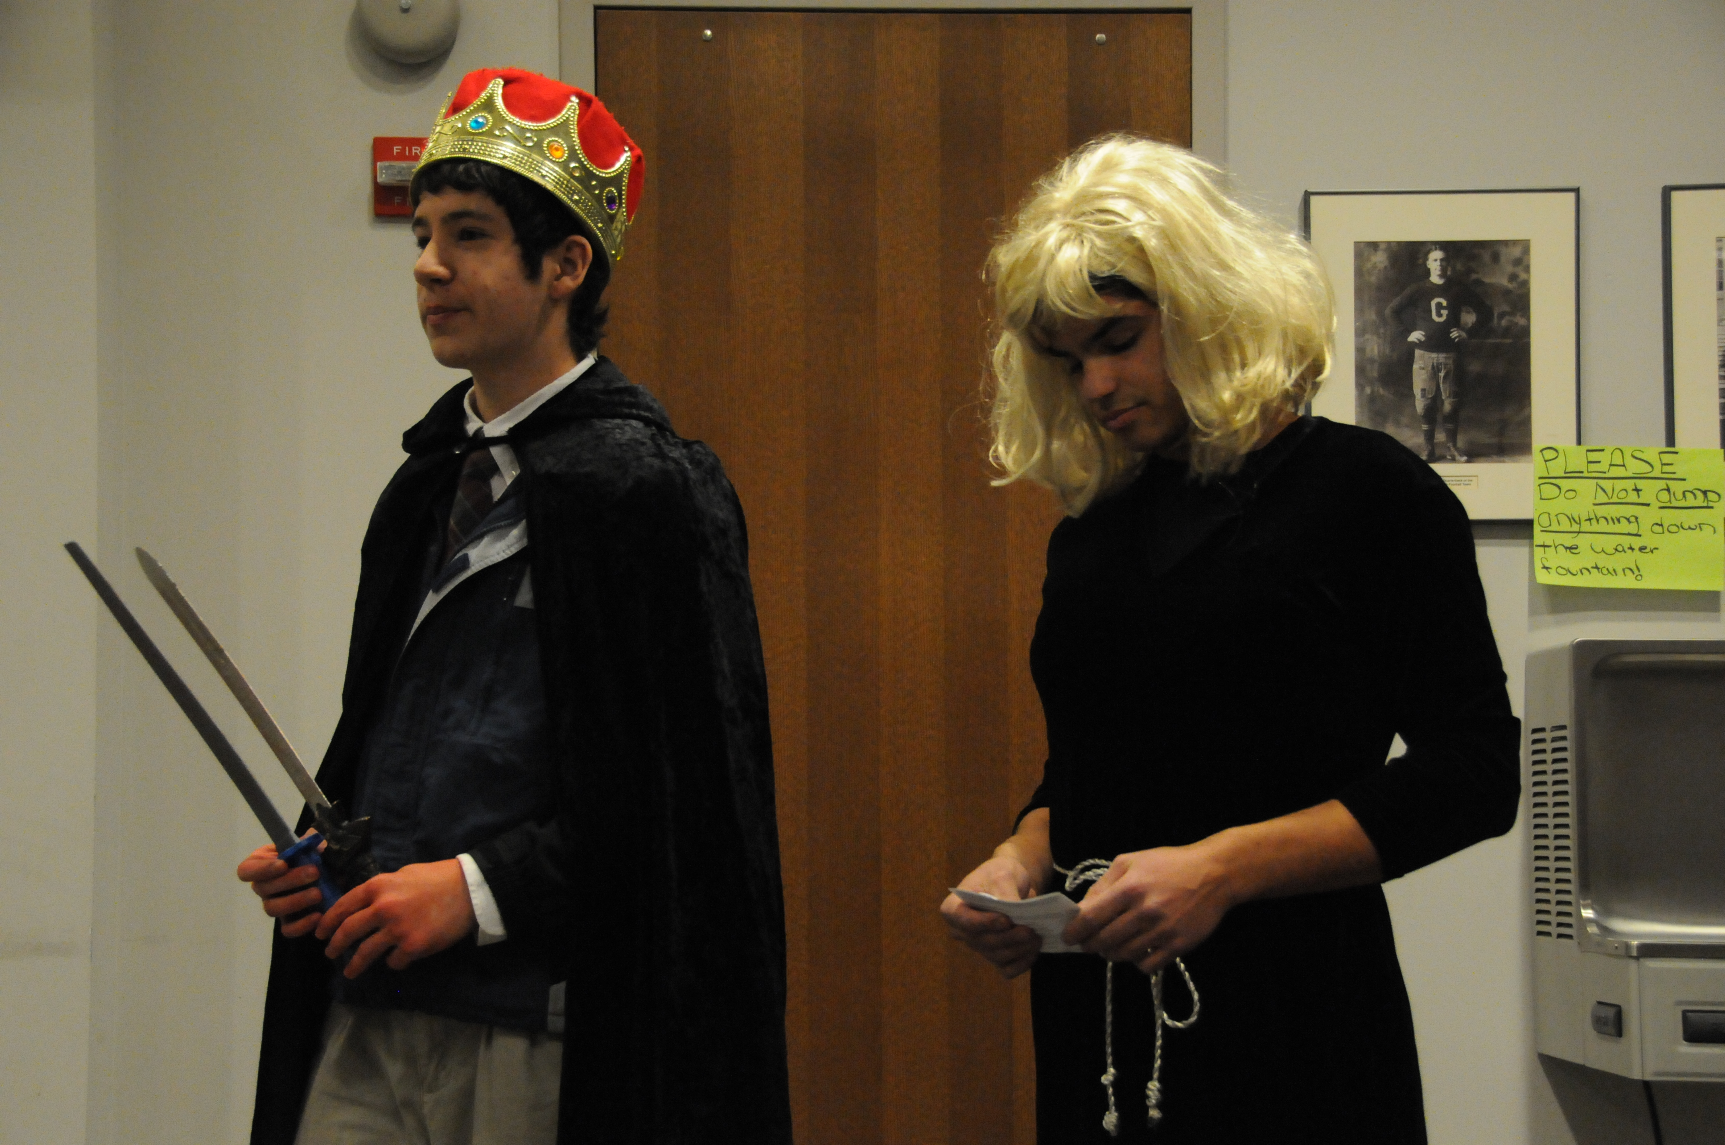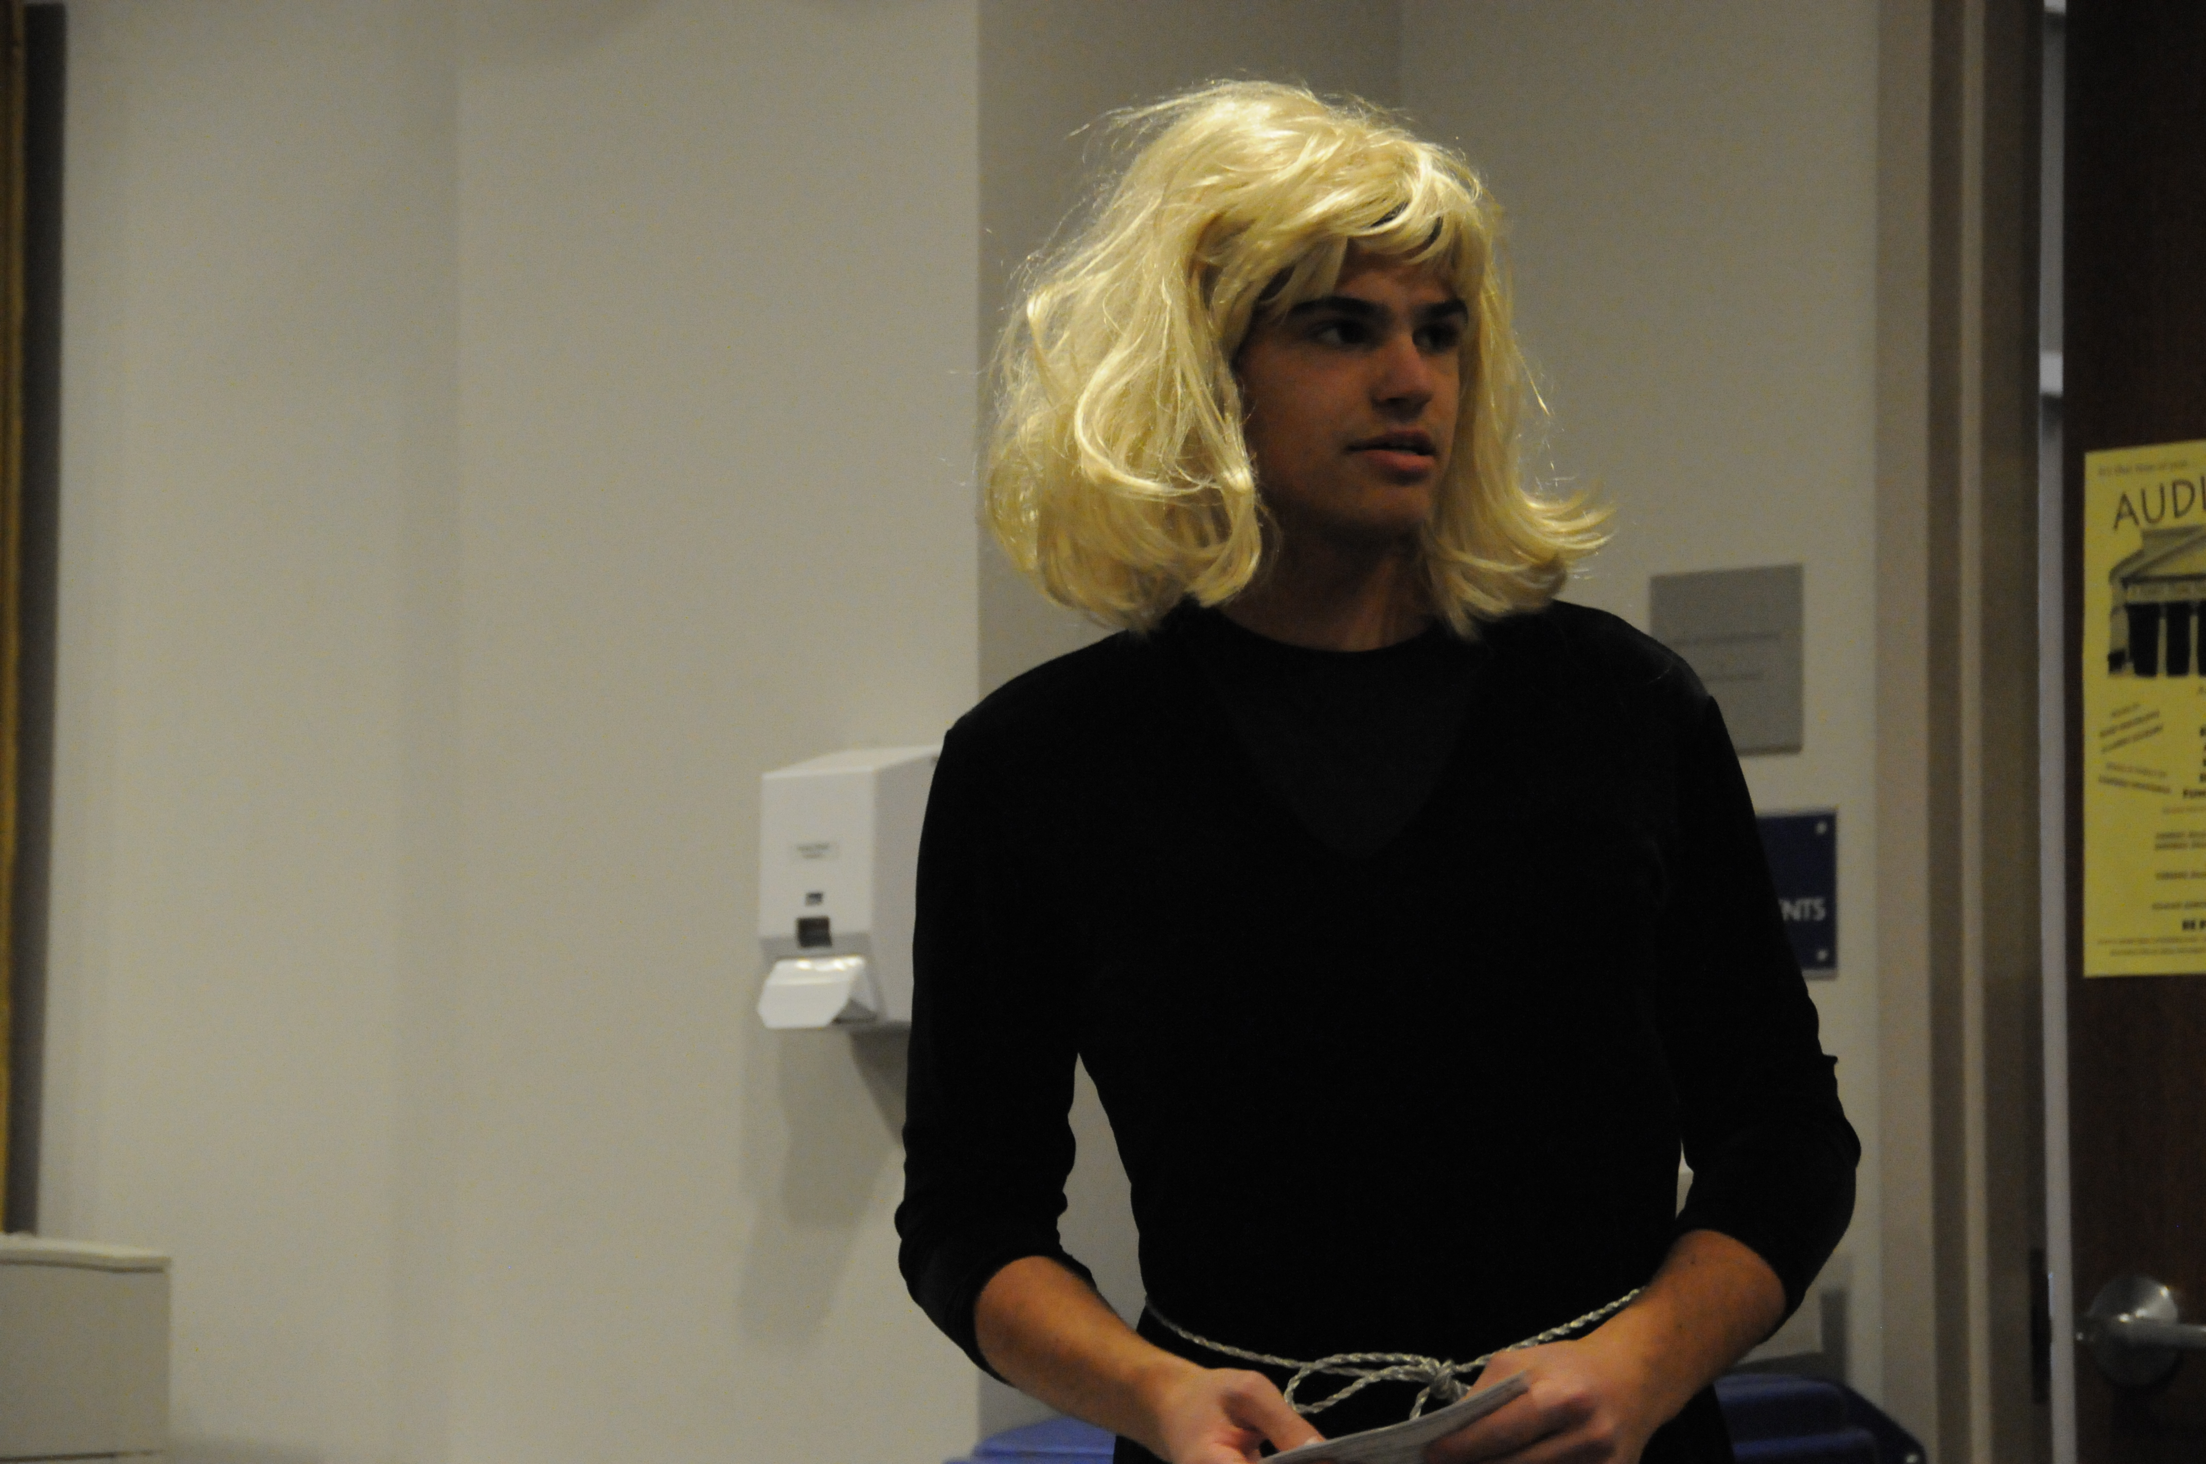
The dark clothes we chose for costumes and the dark lighting we would have used if possible both set the atmosphere as the darkest point of the play.
Macbeth has blood on his hands from the murder, and at a later point in the scene Lady Macbeth gets some blood on her hands as well: we accomplished this with red paint
The daggers are still bloody and smeared with paint after the murder

Character Report: Lady Macbeth

1. What does your character want in this scene?
In this scene, Lady Macbeth wants to control the power in her house, and to gain this power, first she must gain authority over Macbeth by making him do her bidding.
2. What is your character’s motivation for doing what he or she does?
Throughout the play, Lady Macbeth is motivated by power, and in this particular scene, she is prompted by the thought that after Macbeth kills Duncan, she will become queen of Scotland. In essence, this means that she will become in control of all of Scotland because she already has control over the future king, and can tell him to do whatever she desires.
3. What obstacles stand in his or her way?
As Lady Macbeth tries to overcome the obstacle of devising a plan to make sure that they get away with the deed they have committed, she has to deal with the incompetence of Macbeth. To reach her goal of becoming queen, she must mold Macbeth into the person that she wants him to be, which will allow her to make Macbeth’s decisions for him and not let him second guess himself.
4. What happens when your character confronts these obstacles?
When Lady Macbeth confronts these obstacles, she attacks them strait on by taking charge of the situation and showing who is boss. She does not let Macbeth get in-between herself and her goal because this could be interoperated as a sine of weakness, which would exemplify that she does not have the utmost power over Macbeth.
5. Are there any distinctive elements in your character’s way of speaking? (Is his or her language elaborate, plain, or what?)
Throughout this play, and especially in this scene, Lady Macbeth’s tone of voice is very commanding. She constantly has to yell at Macbeth so he will do what she wants, and when we acted out the scene we decided to have Lady Macbeth slap Macbeth when she says “Infirm of purpose!” because she must let out some of this irritated anger that she has built up as a result of his incompetence. Another more subtle characteristic about the way she speaks is that whenever Lady Macbeth is on stage and is talking, the pace of the literary text seems to pick up, and is faster than if it were just Macbeth speaking in a soliloquy.
6. What is your character thinking during the scene? (How does he or she react to the other characters and events?)
In this scene, Lady Macbeth is a very two sided figure. In the beginning when she finds out that Macbeth has murdered Duncan she is very happy and proud of her husband for succeeding in the deed, but she is very easy to anger. As the scene continues, Macbeth refuses to go back and smear the grooms with blood because he is afraid to think of what he has done. This irritates her very much, so indirectly she implies that he is a pusillanimous child, which shows her other side of her character in this scene which is a mad all knowing and controlling woman.
Character Report: Macbeth

1. What does your character want in this scene?
In this scene, Macbeth wants to gain power and become King of Scotland. Later, after he commits the crime he feels remorse and wants forgiveness for his terrible crime, but most of all he wants to undo what he has done and wishes he could escape his relentless conscience.
2. What is your character’s motivation for doing what he or she does?
Macbeth is motivated by his ambition, and by guilt. His ambition drives him to commit murder, in order to gain power, and then his guilt reawakens his latent insecurities and motivates him to seek both escape and solace. His refusal to hand the daggers over to Lady Macbeth is an example of an action motivated by guilt.
3. What obstacles stand in his or her way?
Macbeth must murder Duncan without arousing suspicion, but his fear of failure acts as an obstacle for him. It makes him commit stupid mistakes like forgetting to leave the daggers at the scene of the crime, and after the crime his fear of himself drives him insane right when he needs his wits most. His other desire, to seek repentance and mollify his guilt, is blocked by his wife Lady Macbeth. She insists that he grow up and relegate his conscience to the farthest corners of his mind.
4. What happens when your character confronts these obstacles?
Macbeth tries to control his fear when he murders Duncan but he fails. As a result, the fear of failure turns into a deeper and more dangerous fear: he fears that he has become a monster, and cannot live with the truth of who he is. This insecurity strikes at his very core and undermines the rest of his consciousness until it finally turns him into a mad tyrant. When Macbeth tries to confront Lady Macbeth, she proves the victor and utterly repudiates his feeble claim for independence. He becomes further enslaved to her as a result, and his pride, stinging with the humiliation of her bitter rebukes, is too cowed to resist her ever again.
5. Are there any distinctive elements in your character’s way of speaking? (Is his or her language elaborate, plain, or what?)
Macbeth’s speech is nervous and shaken; he is clearly very traumatized by the murder. He is jumpy and prone to exclamations, such as “Who’s there!” (2.2.11) and “Whence is that knocking?” (2.2.54). The cacophony of sounds such as the endless knocking intimidate him as he fears, irrationally, that he will be discovered. He speaks to himself for long periods of time, ignoring Lady Macbeth’s frequent interruptions; he obsessively returns over and over to the chamber in his mind, wondering why he could not say amen. He is harried and frantic and lashes out at Lady Macbeth when she orders him to take action and stop dithering; these qualities display his own insecurity and crumbling self-confidence.
6. What is your character thinking during the scene? (How does he or she react to the other characters and events?)
Macbeth’s thoughts are revealed in his soliloquy, as per Shakespeare’s custom. Here is Shakespeare’s chance to have Macbeth speak directly to the audience, without the need for interaction with other characters that might make Macbeth hide his true feelings. His soliloquy comes right after Lady Macbeth scolds him and leaves, so it displays his reaction to that rebuke; he wonders what is wrong with him, and worries that he truly is as weak as Lady Macbeth claims. He also displays his heart’s true reaction to the murder; instead of being coldly pleased with its results, as Lady Macbeth would, he is shocked and appalled at his own actions. He makes the allusion to Oedipus, who also felt such horror that he wished to pluck out his own eyes. Macbeth’s horror is that he hates himself, but cannot escape himself; as long as he lives, he is trapped in a nightmare from which he cannot awake.

PHOTOGRAPHS OF KEY MOMENTS

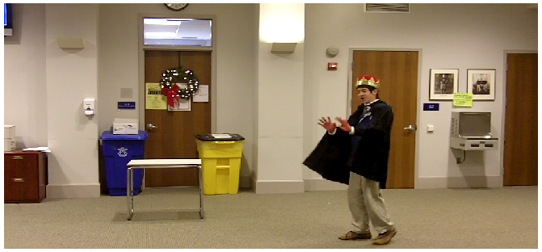

In this photograph, Macbeth is shown describing his hands as ‘hangman’s hands’ to Lady Macbeth. His hands are hangman’s hands because of his recent murder of King Duncan, and this line shows the guilt that he feels over the murder. The gory imagery of a hangman is affixed to Macbeth, and will taint his self-image and thus destroy the confidence required for an ambitious man to retain power. He reveals his vulnerability and lack of confidence in this dialogue, where he questions himself: “wherefore could not I say Amen?”. Macbeth is ashamed that he has committed treason and proven an ungrateful subject, so he cannot respond to the prayer because his self-hatred extends even to his own voice. He cannot stand to listen to himself speak, when that same mouth uttered the lies which drew Duncan into his fatal trap.

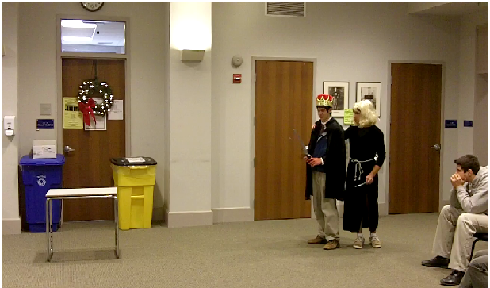
At this moment, Lady Macbeth is shown consoling her husband who is racked with guilt and doubt as demonstrated in the previous photograph. Her words are crucial: she urges Macbeth not to thinks so much about what he has done, lest he go insane. These words are foreshadowing almost prophetically his imminent doom and also explain Lady Macbeth’s character; they reconcile the two hitherto seemingly conflicted halves of her persona. It settles the question of how Lady Macbeth can seem at first a cold, unfeeling machine, and then shortly thereafter a broken and suicidal madwoman: she has a conscience, but subjugates it to her desire for power by repressing it and refusing to think about the moral implications of her actions, preferring instead to maintain a Machiavellian focus solely on the acquisition and retention of power. Her personal philosophy, which she here reveals when she advises Macbeth to emulate her, fails her because the repressed emotions of guilt surface in her subconscious. However, there they cannot be met with reasoned argument and self-justification, but rather overwhelm her to the extent that she is found sleepwalking, and incessantly trying to wash the blood off of her hands.

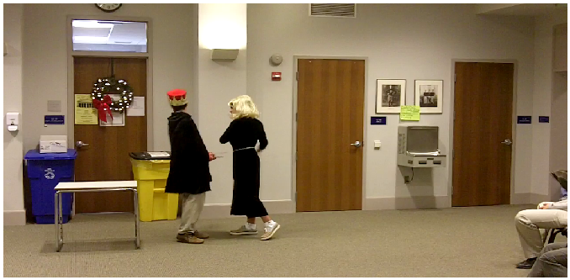

This is the peak of dramatic tension in the scene, where Macbeth is trying for a final time to overcome his now crippling sense of inadequacy and shame. He stands up to Lady Macbeth, who at this moment seems the embodiment of all that he hates; she, for him, represents the forces which have driven him to commit the murder, and it seems to him that he is merely a slave who has done something terrible against his own will. He tries to refuse when Lady Macbeth orders him to wash the blood off his hands, symbolic of his relinquishing his guilt as per Lady Macbeth’s advice in the previous photograph, and to commit a further crime by framing the attendants with the bloody daggers. He says, “I’ll go no more,” and follows with, “I’m afraid to think what I have done”. By confessing his continuing torment from his conscience, Macbeth shows that he has failed to take Lady Macbeth’s advice and cannot repress his conscience as she has done. He is afraid, not of others, but of himself; now that the unflinching eye of his conscience has witnessed these deeds, it will turn inwards and examine the reasons for doing them, and Macbeth will pass judgment upon himself. He is afraid that what he will see, when he admits to himself the truth of his own nature, is going to be impossible to live with. Lady Macbeth is angry that he should continue in this manner, when she knows it will lead to his downfall. She slaps him, and shouts “INFIRM OF PURPOSE!”. For her, this is the worst insult: he is weak. In her world, the ultimate goal is power, and thus ambition has an exalted place because of its essential role in the acquisition of power. Therefore, someone who willingly cripples their ambition with conscience is not strong enough to gain power. Because power is the only goal, Macbeth is a failure. Lady Macbeth displays her authority here and defeats Macbeth’s last attempt at independence, showing once and for all that she is the dominant figure in their relationship.
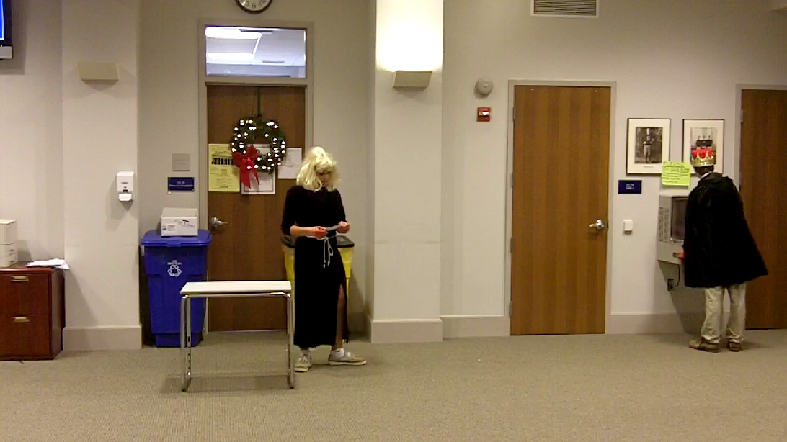

Here Macbeth washes his hand of Duncan’s blood, and symbolically removes from himself the stain of guilt for the murder. He is acceding to Lady Macbeth’s wishes and trying to ignore his conscience after Lady Macbeth has harshly rebuked and humiliated him. If he is a hangman, than he has failed to properly execute the execution, because through his bumbling ineptitude he has forgotten to incriminate others in the crime: the job will be done correctly by the professional, coolheaded Lady Macbeth. Finally Shakespeare makes an allusion to the biblical figure Pontius Pilate through the emphasis on washing hands to remove guilt, for Pilate immortalized this practice when he did so after condemning Jesus to death. Pilate callously justified the murder of an innocent man by blaming it on another group, in this case the Israelites to whom he handed over Jesus to do with as they wished. Pilate attempts to transfer the guilt much like Macbeth, but in both cases they themselves are responsible. Both cave in to pressure from a third party with no qualms about the killing; Lady Macbeth is to blame for planting the idea in Macbeth’s head and bullying him into acting on it, but ultimately it was Macbeth’s responsibility and duty as a subject to refuse her, just as it was Pilate’s duty as a judge to arbitrate justice rather than give in to coercion. Macbeth and his wife can wash their hands as often as they wish, but their attempts to get rid of the guilt are unsuccessful and they can never get rid of that last spot. This last shred of decency in both of them is what effects their inevitable doom.

